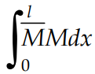 | 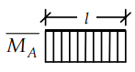 | 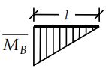 | 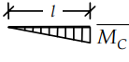 | 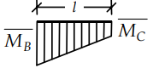
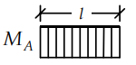 |  | 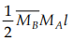 | 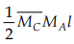 | +
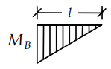 | 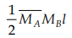 | 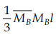 | 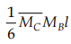 | +
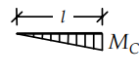 | 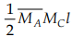 | 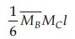 | 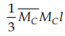 | +
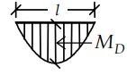 | 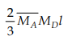 | 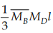 | 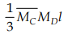 | +
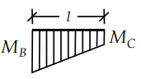 | + | + | + | +++
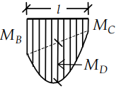 | ++ | ++ | ++ | +++++
Obs.: M_{D} = qL²/8

